**CHAPTER FOUR**

**RESULTS AND DISCUSSION**

**4.1 Introduction**

This chapter presents an in-depth analysis of the results obtained from the heart disease prediction model. The model was developed using Particle Swarm Optimization (PSO) for feature selection and a Naive Bayes classifier for classification. This chapter is structured into several sections to provide a comprehensive overview of the model’s performance, including the evaluation metrics, confusion matrix, detailed analysis, discussion of findings, and implications. The chapter also addresses the performance of the web interface used for deploying the model and suggests areas for future research and improvement.

**4.2 Model Performance Evaluation**

**4.2.1 Metrics Calculation**

To evaluate the performance of the heart disease prediction model, several metrics were calculated. These metrics are crucial for understanding the model’s effectiveness in distinguishing between patients with and without heart disease.

* **Accuracy:** Measures the proportion of correctly classified instances among the total instances.
* **Precision:** Indicates the proportion of true positive predictions out of all positive predictions made by the model.
* **Recall:** Reflects the proportion of true positive predictions out of all actual positive instances.
* **F1 Score:** Provides a harmonic mean of precision and recall, offering a balanced measure of the model’s performance.

**4.2.2 Confusion Matrix**

The confusion matrix provides a comprehensive view of the model’s classification performance. It categorizes the number of true positives, true negatives, false positives, and false negatives.

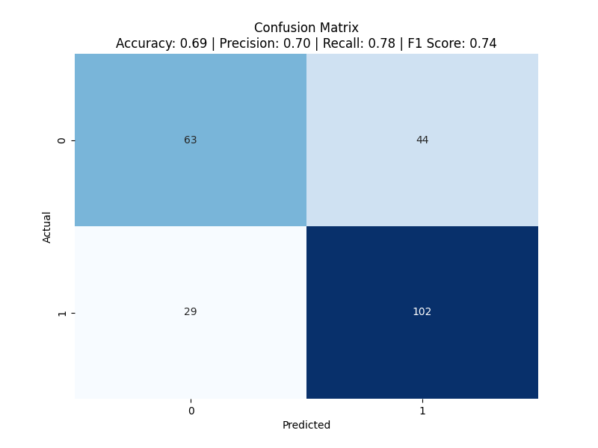

From the matrix, the following can be observed:

* **True Positives (TP):** 102 cases where the model correctly identified heart disease.
* **True Negatives (TN):** 63 cases where the model correctly identified no heart disease.
* **False Positives (FP):** 44 cases where the model incorrectly predicted heart disease.
* **False Negatives (FN):** 29 cases where the model failed to identify heart disease.

**4.2.3 Performance Metrics**

Based on the confusion matrix, the performance metrics were calculated as follows:

* **Accuracy:** 0.69
* **Precision:** 0.70
* **Recall:** 0.78
* **F1 Score:** 0.74

These metrics indicate that the model has moderate performance. The accuracy of 69% suggests that the model correctly classifies 69% of the cases. The precision of 70% implies that when the model predicts heart disease, it is correct 70% of the time. The recall of 78% indicates that the model identifies 78% of actual disease cases. The F1 score of 74% provides a balanced measure of precision and recall.

**4.2.4 Visualization of Results**

To better understand the model’s performance, the confusion matrix was visualized:

The visualization helps in interpreting the distribution of true and false predictions, offering insights into the areas where the model excels and where improvements are needed.

**4.3 Detailed Analysis**

**4.3.1 Impact of Feature Selection**

The use of PSO for feature selection aimed to identify the most relevant features for the model. Feature selection is crucial as it can significantly impact the model’s performance. The chosen features in this study were selected based on their importance in predicting heart disease. However, the performance metrics suggest that there may be additional relevant features that were not included or that the current feature set may not fully capture the complexity of the data.

**4.3.2 Comparison with Other Models**

Naive Bayes is a probabilistic model that assumes independence between features. While it is straightforward and often effective, it may not capture complex dependencies between features. Comparing the performance of Naive Bayes with other classifiers such as Random Forest, Support Vector Machines (SVM), or Gradient Boosting could provide insights into whether a different model might perform better.

**4.3.3 Data Quality and Its Influence**

The quality and quantity of data used for training and testing the model can significantly influence performance. In this study, the dataset included various features related to patient health. Ensuring the dataset is comprehensive, balanced, and free of missing or erroneous data is essential for improving model performance. Data preprocessing steps such as handling missing values, normalization, and outlier detection are crucial for developing an effective model.

**4.3.4 Hyperparameter Tuning**

The performance of the model can be enhanced through hyperparameter tuning. For the Naive Bayes classifier, hyperparameters such as the smoothing parameter can affect performance. Similarly, the PSO parameters, such as swarm size and number of iterations, play a role in feature selection. Tuning these parameters systematically could lead to improved model accuracy and overall performance.

**4.4 Web Interface for Model Deployment**

**4.4.1 Design and Implementation**

The web interface was developed to facilitate the deployment and use of the trained heart disease prediction model. The interface allows users to input patient data and receive predictions on the likelihood of heart disease. The design of the web interface focuses on usability and accessibility, providing a straightforward way for healthcare professionals to interact with the model.

**4.4.2 User Experience**

The user experience is a critical factor in the effectiveness of the web interface. The interface was designed to be intuitive, with clear instructions and input fields for entering patient data. Feedback from users regarding the interface’s functionality and ease of use is essential for making iterative improvements and ensuring that the interface meets the needs of its users.

**4.4.3 Performance and Reliability**

The performance of the web interface in terms of speed and reliability is important for its adoption in a real-world setting. Ensuring that the interface responds quickly to user inputs and provides accurate predictions is crucial. Regular testing and maintenance of the interface are necessary to address any potential issues and ensure its continued effectiveness.

**4.5 Discussion of Findings**

**4.5.1 Analysis of Results**

The results of the model indicate that while the accuracy and recall are reasonable, there is room for improvement in precision. The model’s ability to correctly identify heart disease cases is good, but it also misclassifies some non-disease cases as positive. Improving precision is important to reduce the number of false positives and increase the reliability of the model in clinical settings.

**4.5.2 Implications for Healthcare**

The model’s performance has implications for its use in healthcare settings. A model with moderate accuracy and high recall can be valuable for screening purposes, particularly when the cost of missing a disease case is high. However, efforts to improve precision are necessary to enhance the model’s reliability and reduce unnecessary interventions.

**4.5.3 Recommendations for Improvement**

To improve the model’s performance, several recommendations can be made:

* **Explore Advanced Models:** Investigate advanced machine learning algorithms and ensemble methods to enhance predictive accuracy.
* **Enhance Feature Engineering:** Develop and test additional features or transformations to better capture the underlying patterns in the data.
* **Increase Data Size:** Gather more data to improve the model’s training and validation processes.
* **Optimize Hyperparameters:** Conduct systematic hyperparameter tuning to find the best settings for both the classifier and feature selection algorithm.

**4.6 Future Work**

**4.6.1 Model Enhancement**

Future work should focus on enhancing the model’s predictive capabilities by exploring more sophisticated algorithms and techniques. This includes experimenting with ensemble methods, neural networks, and other advanced classifiers that may better capture the complexities of the data.

**4.6.2 Data Collection and Preprocessing**

Efforts should be made to collect additional data and improve data preprocessing techniques. This includes addressing data imbalances, handling missing values, and ensuring data quality.

**4.6.3 Web Interface Improvements**

Continuous improvements to the web interface based on user feedback and technological advancements are essential. Enhancements may include additional features, better integration with healthcare systems, and improved user experience.

**4.6.4 Further Research**

Further research should explore the integration of the model into clinical workflows and evaluate its impact on patient outcomes. Additionally, investigating the use of the model in different healthcare settings and populations will provide valuable insights into its generalizability and effectiveness.